Created by: ICT
Approved by: Corporation
Date approved: July 2026
Policy review date: July 2028

Document Name: Data Rights Policy and Procedure
Document Ref: DP1.02
Pre-approval at: EMT/Audit Committee/Corporation
Type of Doc: Policy
Publishing Requirement Staff Sharepoint/Student Intranet/Webpage

Version | Author | Date | Changes
1 | DPO | June 2026 | Revisions to align with Data Policy Suite. Minor clarification amendments.

- Policy Introduction

The policy will help inform you about the data the College requires and holds about you and will also set out the legal reasons we handle this data. You will also be informed how to exercise your rights and the procedures for how to make a request.

This policy forms part of the College’s Data Protection Policy Suite and should be read alongside the GDPR Policy (DP1.01), Privacy Policy (DP1.04), Data Retention Policy (DP1.05) and Data Breach Policy (DP1.06).

2. Responsibility & Implementation

2.1 You have the following rights over your data, you may not choose to exercise any of these rights however it is important that you are well informed and have the right knowledge.

All College Personnel must ensure that any request relating to these rights is escalated to the Data Protection Officer in accordance with this policy.

The right to be informed
Individuals have the right to be informed about the collection and use of their personal data. This information can be found in the College's privacy policy.

The right of access
Individuals have the right to access their personal data. This is known as a subject access request (SAR).

The right to rectification
This is the right for individuals to have inaccurate personal data rectified, or completed if it is incomplete.

The right to erasure
The right for individuals to have personal data erased, known as ‘the right to be forgotten’.

The right to restrict processing
Individuals have the right to request the restriction or suppression of their personal data. This is not an absolute right and only applies in certain circumstances.

The right to data portability
This right allows individuals to obtain and reuse their personal data for their own purposes across different services. You can request the transfer of your personal data to another in a safe and secure way, without affecting its usability.

The right to object
Individuals have the right to object to the processing of their personal data in certain circumstances.

Rights in relation to automated decision making and profiling
Where a decision is made solely by automated means without any human involvement, you have the right to be informed if your data is used in this way.

For further details on each right, and where exclusions may apply see Appendix 1, pages 5-9

How does the College allow individuals to exercise their rights?

The college collects a lot of personal data under the legal basis of Public Task. This means we have to collect and record information, such as the personal data on our enrolment forms, as set out in law by the government for courses that are publicly funded.

Where individuals receive funding for their course we have a duty to collect information to confirm their eligibility, monitor their learning and ensure they are protected whilst they are studying at one of our campuses. It is therefore important that your rights in relation to your personal data are clear.

The Procedures for exercising your rights are detailed in the following diagram.
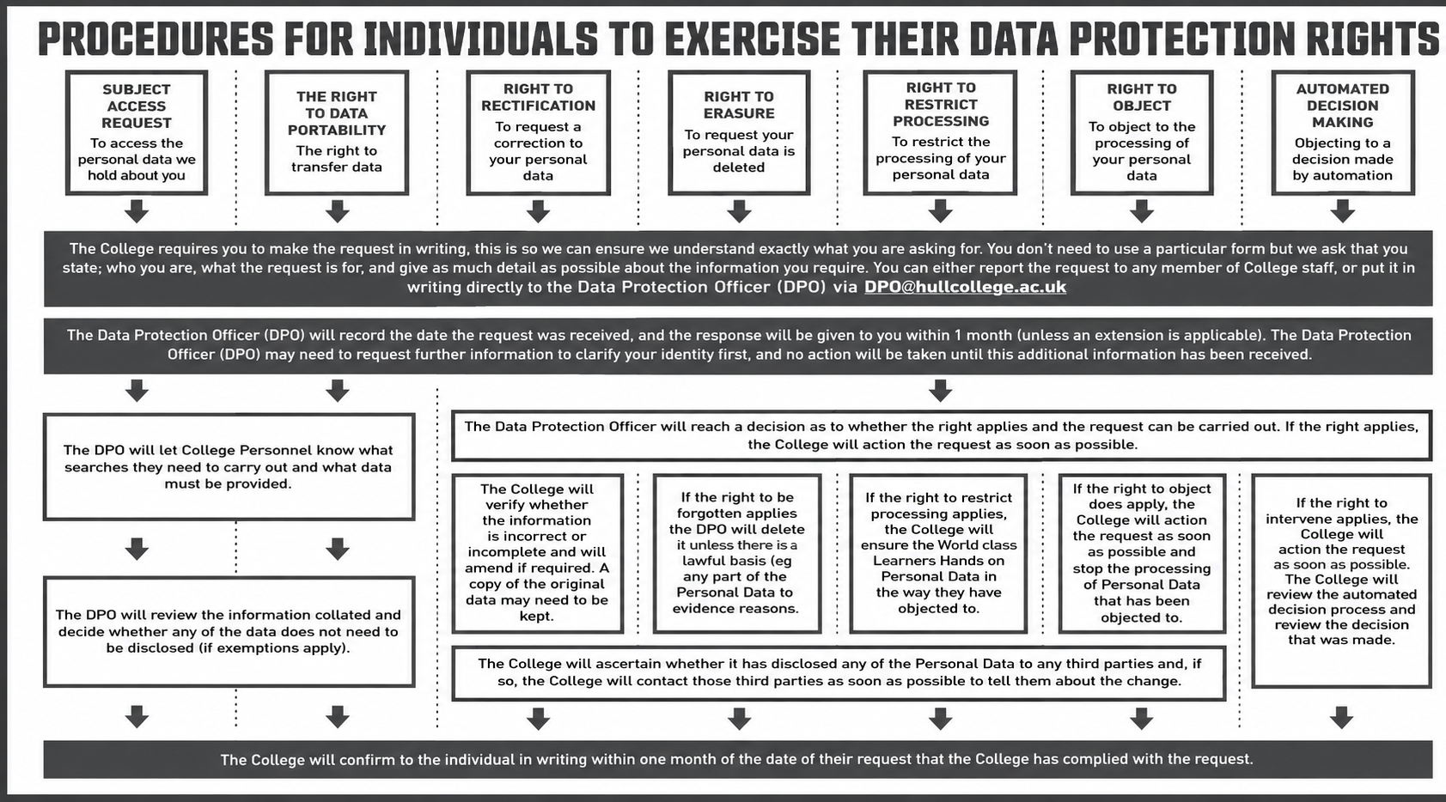

Are there any requests the College does not have to respond to?
If the request the College receives from an individual is unfounded or excessive then the College may either:

refuse to action the request; or

charge a reasonable fee taking into consideration the College’s administrative costs of providing the information or taking the action requested.

Any decisions made, or the charging of a fee, shall be made by the Data Protection Officer. (all such decisions must be documented by the Data Protection Officer for audit purposes)

All requests set out above must be responded to within a month unless the request is complex in which case the period may be extended up to a further two months. Any decision in relation to whether the request is complex is to be made by the Data Protection Officer who shall inform the individual making the request of the extension. Any notification of the extension to the individual shall be made within the initial one-month period and shall give reasons for the delay. The one-month response period begins once the College has received the request and verified the identity of the requester. The timescale may be paused where identity verification is required.

The College will take reasonable steps to verify the identity of the individual before responding to any rights request.

If the College is not going to action the request made by an individual, the Data Protection Officer will also communicate this to them within a month of receipt of the request. The communication shall include details of the College’s reasons for not complying with the request and the ability of the individual to make a complaint to the ICO.

If you have any further questions about the policy, or you rights, please contact the College Data Protection Officer, via the main college telephone number 01482 598795 or on email via DSAR@Hull-College.ac.uk

5. Monitoring and Review

5.1 This policy will be monitored by the Data Protection Officer “DPO” on a bi-annual basis, unless changes in legislation require earlier review.

Appendix 1

Further detail on rights individuals have over their personal data

1. Right of access (subject access requests)

1.1 Individuals have the right to ask the College to confirm the Personal Data they are holding about them, and to have copies of that Personal Data (commonly known as a Subject Access Request) and

1.1.1 how long the College will keep their Personal Data;

1.1.2 that they have the right to request that the College corrects any inaccuracies in their Personal Data or deletes their Personal Data (in certain circumstances, please see below for further information); or restrict the uses the College is making of their Personal Data (in certain circumstances, please see below for further information); or to object to the uses the College is making of their Personal Data (in certain circumstances, please see below for further information);

1.1.3 that they have the right to complain to the ICO if they are unhappy about how the College has dealt with this request or in general about the way the College is handling their Personal Data;

1.1.4 where the Personal Data was not collected from them, where the College got it from; and

1.1.5 the existence of automated decision-making, including profiling (if applicable).

1.2. The College will not charge individuals for complying with this request. However, if the individual would like a further copy of the information requested, the College can charge a reasonable fee based on its administrative costs of making a further copy.

1.3. There are no formality requirements to making a Subject Access Request, but the college asks that they are made in writing so there can be no misinterpretation of what is being requested.

1.4. The College is required to respond to a Subject Access Request within one month from the date the College receives it. If the request is complex or there are multiple requests at once, the College may extend this period by two further months provided that the College tells the individual who has made the request about the delay and the College’s reasons for the delay within the first month

1.5. The Data Protection Officer will reach a decision as to the complexity of the Subject Access Request and whether the College is entitled to extend the deadline for responding.

2. Right to rectification

2.1. Individuals have the right to ask the College to correct any Personal Data about them that the College is holding that is incorrect. The College is then obliged to correct that Personal Data within one month (or two months if the request is complex).

2.2. Where the individual tells the College their Personal Data is incomplete, the College is obliged to complete it if the individual asks the College to do so. This may mean adding a supplementary statement to their personal file for example.

2.3. If the College has disclosed the individual’s inaccurate Personal Data to any third parties, the College is required to tell the individual who those third parties are and to inform the third parties of the correction where the College can.

2.4. When an individual asks the College to correct their Personal Data, the College is required to do so and to confirm this in writing to the individual within one month of them making the request.

3. Right to erasure (right to be forgotten)

3.1. Individuals have the right to ask the College to delete the Personal Data the College has about them when:

3.1.1 the Personal Data is no longer necessary for the purpose the College collected it for;

3.1.2 the individual withdraws consent and the College has no other legal basis to use their Personal Data;

3.1.3 the individual objects to the College’s processing and there is no overriding legitimate interest for continuing the processing;

3.1.4 the Personal Data was unlawfully processed; and/or

3.1.5 the Personal Data has to be erased to comply with a legal obligation.

3.2. If the College has disclosed the individual’s deleted Personal Data to any third parties, the College is required to tell the individual who those third parties are and to inform the third parties to delete the Personal Data where the College can.

3.3. When an individual asks the College to delete their Personal Data, the College is required to do so and to inform the individual in writing within one month of them making the request that this has been done.

4. Right to restrict processing

4.1. Individuals have the right to “block” or “suppress” the College’s processing of their Personal Data when:

4.1.1 they contest the accuracy of the Personal Data, for a period enabling the College to verify the accuracy of the Personal Data;

4.1.2 the processing is unlawful and the individual opposes the deletion of the Personal Data and requests restriction instead;

4.1.3 the College no longer needs the Personal Data for the purposes the College collected it for, but the College is required by the individual to keep the Personal Data for the establishment, exercise or defence of legal claims;

4.1.4 the individual has objected to the College’s legitimate interests, for a period enabling the College to verify whether its legitimate interests override their interests.

4.2. If the College has disclosed the individual’s restricted Personal Data to any third parties, the College is required to tell the individual who those third parties are and to inform the third parties about the restriction where the College can.

4.3. When an individual asks the College to restrict its processing of their Personal Data, the College is required to do so and to confirm to the individual in writing within one month of them making the request that this has been done.

5. Right to data portability

5.1. Individuals have the right to obtain from the College a copy of their own Personal Data in a structured, commonly-used and machine-readable format (such as CSV files). The aim of this right is to facilitate the ability of individuals to move, copy or transmit their Personal Data easily from one IT environment to another.

5.2. The right to data portability only applies when:

5.2.1 the individual provided the College with the Personal Data;

5.2.2 the processing the College is carrying out is based on the individual’s consent or is necessary for the performance of a contract; and

5.2.3 the processing is carried out by automated means.

5.3. This means that the right to data portability does not apply to personal data the College is processing on another legal basis, such as its legitimate interests.

5.4. The College is obliged to provide this information free of charge within one month of the individual making the request (or two months where the request is complex provided that the College explains to the individual why it needs more time).

5.5. The individual also has the right to ask the College to transmit the Personal data directly to another organisation if this is technically possible.

6. Right to object

6.1. Individuals have the right to object to the College’s processing of their Personal Data where:

6.1.1 the College’s processing is based on its legitimate interests or the performance of a task in the public interest and the individual has grounds relating to his or her particular situation on which to object;

6.1.2 the College is carrying out direct marketing to the individual; and/or

6.1.3 the College’s processing is for the purpose of scientific/historical research and statistics and the individual has grounds relating to his or her particular situation on which to object.

6.2. If an individual has grounds to object to the College’s legitimate interests, the College must stop processing their Personal Data unless the College has compelling legitimate grounds for the processing which override the interests of the individual, or where the processing is for the establishment, exercise or defence of legal claims.

6.3. If an individual objects to direct marketing, the College must stop processing their Personal Data for these purposes as soon as the College receives the request. The College cannot refuse their request for any reason and cannot charge them for complying with it.

6.4. Before the end of one month from the date the College gets the request, the College must notify the individual in writing that the College has complied or intends to comply with their objections or that the College is not complying and the reasons why.

7. Rights in relation to automated decision making

7.1. Individuals have the right not to be subject to a decision based solely on automated processing, including profiling, which produces legal effects concerning him or her or similarly significantly affects him or her unless the decision is:

7.1.1 necessary for entering into or performing a contract between the College and the individual;

7.1.2 required or authorised by Data Protection Laws; or

7.1.3 based on the individual’s explicit consent.

Automated decision making happens where the College makes a decision about an individual solely by automated means without any human involvement; and

Profiling happens where the College automatically uses Personal Data to evaluate certain things about an individual.

