Gender Pay Gap Report 31 March 2025
Our calculations are based on pay data for 537 members of staff on 31 March 2025 as required by the mandatory gender pay gap reporting regulations. The data includes many different roles and levels within the College that have a variety of pay rates.

A pay gap is a measure of the difference between the average earnings between two groups.

The mean pay gap is the difference in the arithmetic average hourly pay for one group compared to the other (in this case men vs women), within our organisation.

The median pay gap represents the middle point of a population. If you lined up all our women and all our men in order of the hourly rate at which they are paid, the median pay gap is the difference between the hourly rate for the middle woman compared to that of the middle man.

Our Pay Gap is not an indicator of Equal Pay issues. Equal pay means that there should be no difference in the contractual terms of a woman and a man doing equal work, who both work for the same employer. This is addressed at source through fair recruitment and promotion practices along with clear salary scales for each job role.

Our Results 2025:
Our pay data as at 31 March 2025 shows the overall difference between men and women;

- Mean gender pay gap = 6.2%
- Median gender pay gap = 12.3%

This means that, on average, female staff were paid less than male staff.

The median gender pay gap shows that hourly pay for men is, on average, 6.2% higher than for women. The main reason for this is that the lowest paid quartiles contain a higher % of women thus bringing down the average.

The median gender pay gap shows that the ‘middle’ man in the organisation, is paid 12.3% higher than the ‘middle’ woman. Again, this is influenced by the higher concentration of women sitting in the lowest paid quartile.

The table below shows the trend for Hull College over time. There is a clear trend in a reduction in the gender pay gap at Hull College over time.

Year | Mean Gender Pay Gap | Median Gender Pay Gap
2025 | 6.2% | 12.3%
2024 | 6.9% | 17.1%
2023 | 9.5% | 20.7%
2022 | 10.8% | 21%
2021 | 9.17% | 21.28%

The percentage of male and female staff employed across 4 equally sized quartiles are shown below for 2023, 2024 and 2025.

The headcount in the highest paid quartile shows an almost equal gender split indicating that opportunities for appointment and progression are afforded equally to men and women at Hull College.

2025

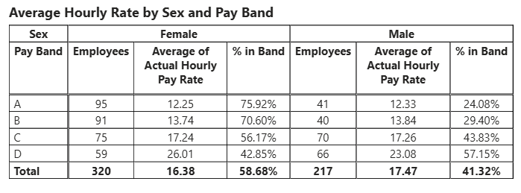

2024

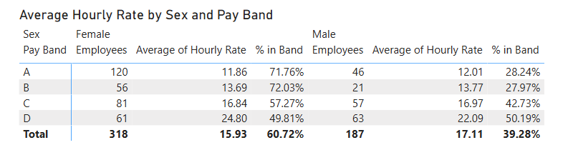

2023

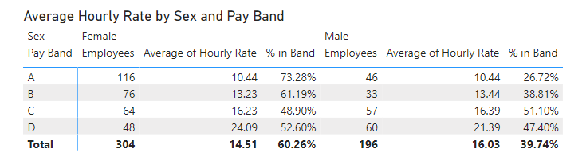

Bonus Payments
The college has not made any bonus payments in the course of the years being reported.

