Privacy Notice for 14+ Learners
What is a Privacy Notice?  The purpose of a privacy notice is to explain to people why we collect your personal data, how we use it and how we protect it.  So you feel confident in the knowledge that we are safeguarding and protecting your information.  Our Data Protection Officer (DPO) is responsible for the General Data Protection Regulation, contact our DPO on GDPR-Request@Hull-College.ac.uk | 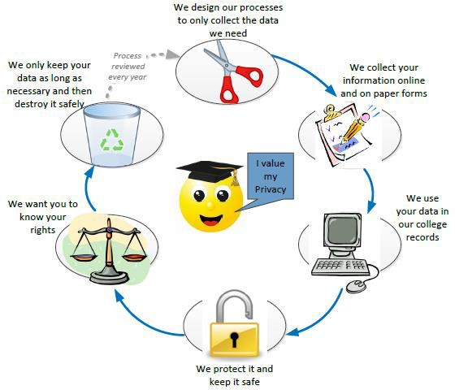

The personal information that you give us
As part of your application and enrolment to the college we collect personal information from you including name, contact details, date of birth, guardian or emergency contact, ethnicity, learning difficulties and disabilties, health information, criminal convictions, your photo and employment status. We may also collect payment details if you are paying for your course or if you are in receipt of a bursary.
We also collect information whilst you are studying with us to monitor your progression as well as to support your learning as part of your studies and individual learning plan. This includes information relating to your attendance, behaviour, support requirements, targets, predicted grades, achievements and progression plans.

How we use your personal information in the college
We will use your information to manage your education, provide welfare and pastoral care, to track your progress so we can help you achieve the best you can. This may include every day activities such as creating classlists for your teacher at the start of the course, providing registers for your tutor to mark your attendance, registering with the awarding bodies to allow us to enter you for your exams, or providing you with a support plan or exam assessment. We also use this information to improve and develop teaching and services in the future.
We will not send you marketing information unless you have opted in to receive these during the enrolment process and we will only contact you through the methods you chose.

The legal basis on which we collect and use your personal information.
Generally, the information we collect is part of our public interest task of providing education to you. This allows us to collect the information we need on behalf of the government to draw down funding on your behalf or to process your achievements.
Some of the data we collect is deemed to be ‘special’ category (such as ethnicity, health or criminal convictions) but we process it because there is a substantial public interest for us to do so, and we also have to ensure a safe and secure environment for all learners and staff.

How long we keep your personal information
As part of the public task where you have received funding for your course we are expected to keep your enrolment records for at least 7 years for eligibility checks. This is for audit purposes and to ensure we have evidence for why you were entitled to receive funding for your education. We may also retain other information relating to health and safety incidents, information relating

to the childcare legislation for diffferent periods but we will not keep these for any longer than we are legally required to.

How we share your personal information
As part of the public task placed on us by the Education and Skills Funding Agency (ESFA) and the Department for Education (DfE) to fund your education we have a duty to provide them with eligibility, enrolment and achievement data. We also provide them with data to enable you to access additional grants for pupil premium and free schools meals. We use your unique learner number (ULN) to share data with the Learning Records Service (LRS) for your qualifications.
We may also share the personal information that you give us with local authorities and schools but only in relation to your studies. This may include offers, your chosen course, support information, destinations, or transfering information to other educational institutions you move to.
Young people have to remain in training or education until they are 18, so if you withdraw from our education programme before this age then we notify the local authority to highlight you may have become ‘Not in Education, Employment or Training’ (NEET). As part of the same legal duty we share data relating to destinations, or supporting data for careers and youth services. In both circumstances this will only be shared with the relevant local authorities on a need to know basis.
For students studying Higher Education courses with us you will be asked to participate in two external surveys; the National Student Survey (https://www.thestudentsurvey.com/) and the Graduation Outcomes Survey (https://www.hesa.ac.uk/innovation/outcomes/students). The National Student Survey is aimed at final undergraduate students which gathers opinions about their time in higher education on their course and at their institution. The Graduate Outcomes survey captures information about the activities and perspectives of graduates 6 months after they finish their studies. We will hold your contact details after you graduate to enable completion of this survey. You have the right to object to HESA contacting you for the Graduate Outcomes survey. If you don't want to be contacted for the survey email info@graduateoutcomes.ac.uk.
All learners enrolled on an apprenticeship will have summary attendance data and their achievements shared with their employer but only in conjuction with their apprenticeship. We will only share data with an employer about a learning difficulty or disability, or an EHCP plan, if the apprentice is assessed at the start, or during their programme, as needing additional support.
We may also share your personal information with third parties who provide services and support to the College or students but this will always be limited to only the information required.

Do we transfer your personal information outside Europe?
The college does not store or transfer your personal data outside Europe or EEA countries.

How do you request access to your personal information?
You have the right to request access to the personal information we hold about you at any time and the best way to request this is to send an email to GDPR-Request@Hull-College.ac.uk
You also have rights over the way we process your personal information as follows:
- the right to make a complaint to the Information Commissioner’s Office (ICO) if you are unhappy about the way your data is being used - see ICO’s website https://ico.org.uk/
- the right to ask us to correct any errors in your personal information;
- the right to ask us to delete your personal information, in certain circumstances where information was given only by consent and the data was not collected as public task.
- the right to request that we restrict the use of your personal data, in circumstances where this information is not, or no longer required (such as not sharing with family members)
For more information please see our GDPR page https://www.hull-college.ac.uk/the-college/data-protection-gdpr Our Data Protection Officer is Lisa Cheetham. If you have any questions about this notice or how we use your personal information, please contact us on GDPR-Request@Hull-College.ac.uk

