
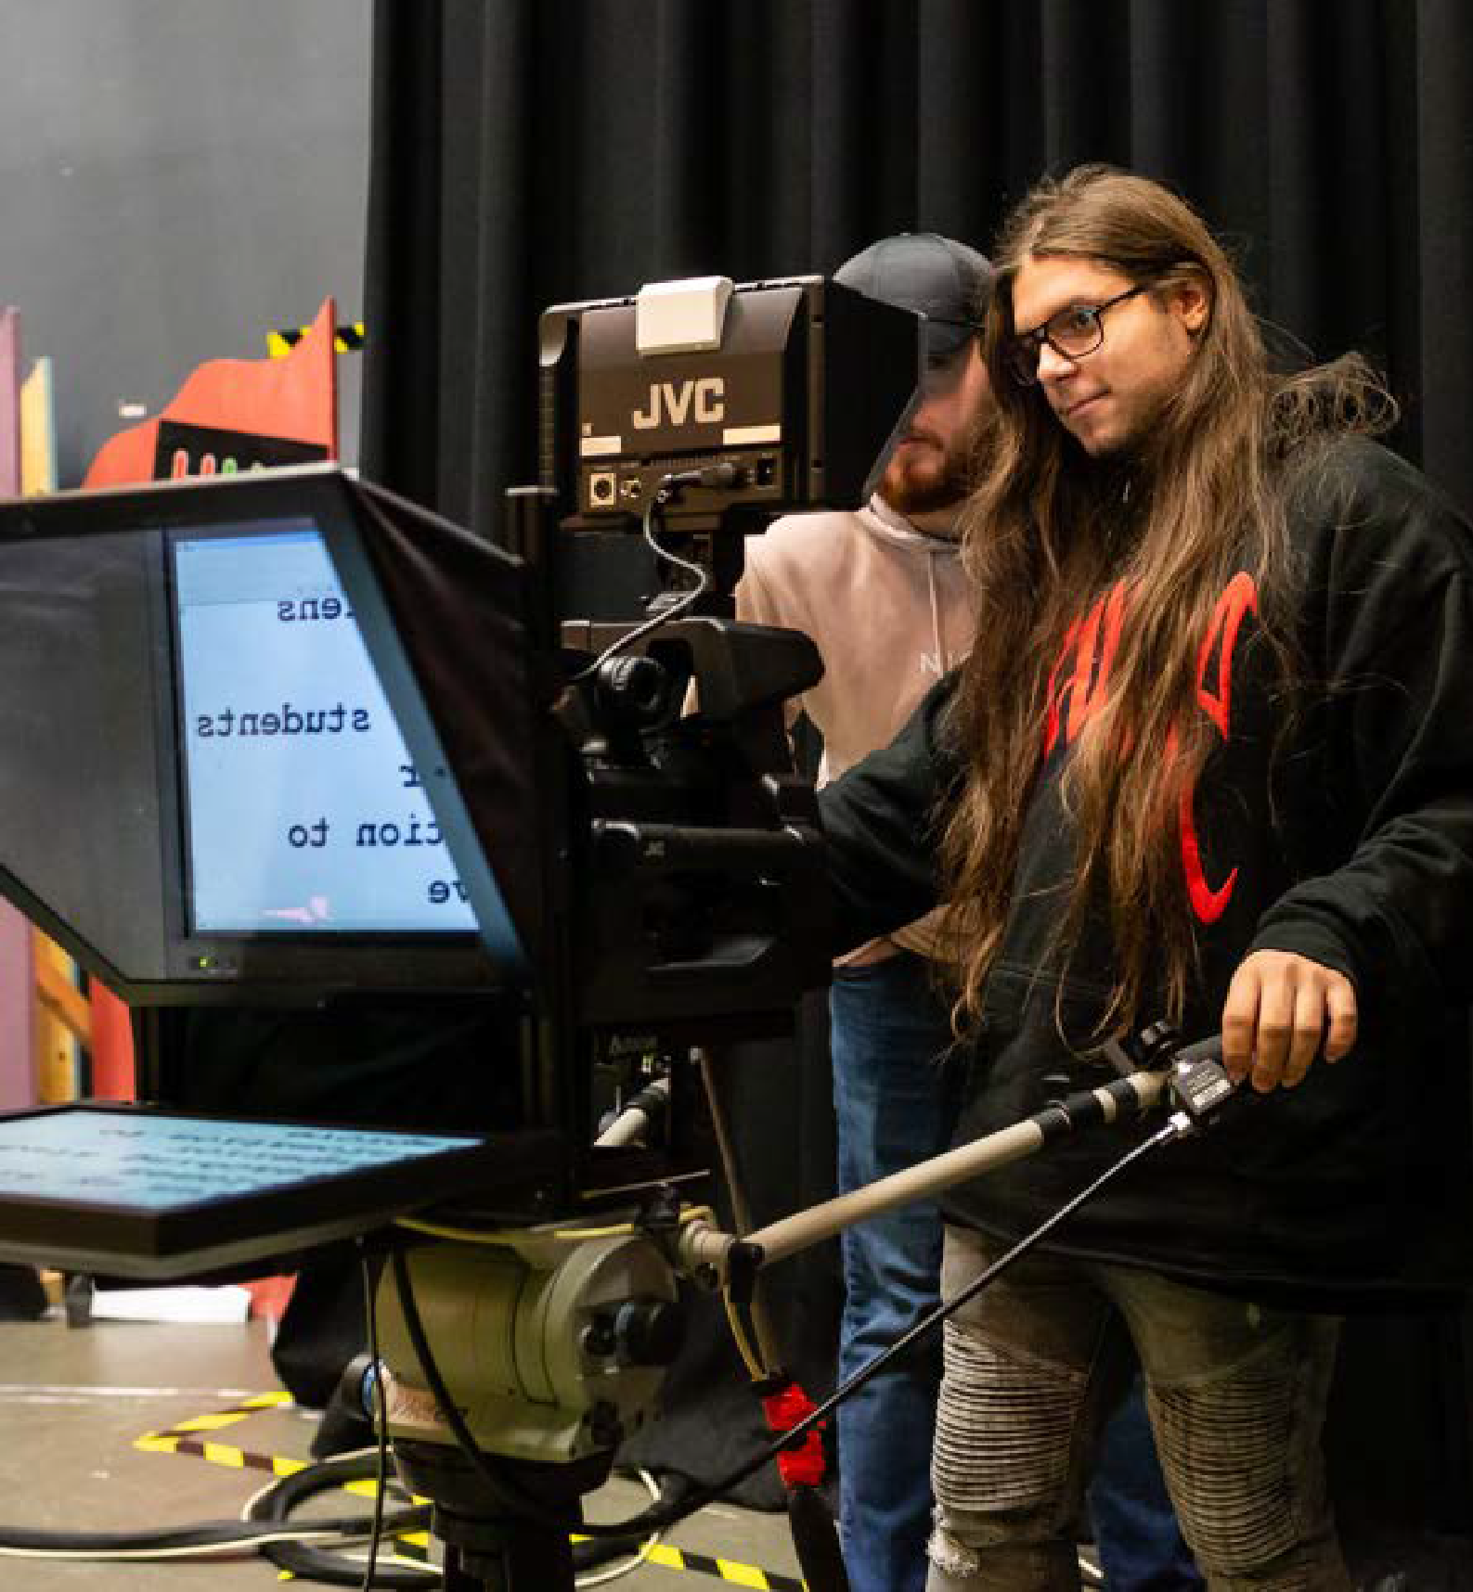


LOCAL NEEDS DUTY & ACCOUNTABILITY AGREEMENT 2025/26

www.hull-college.ac.uk | 1

Hull College Mission Statement: Inspiring, empowering, educating young people and adults in Hull to real-ise their full potential.

Our Intent:
Hull College in 2025 will be a
vibrant, sustainable, and inclusive col-lege meeting the diverse needs
of young people and adults.

2 | ACCOUNTABILITY AGREEMENT

SECTION 1: PURPOSE & KEY PRIORITIES SECTION 2: CONTEXT & PLACE
CONTENTS
SECTION 3: MEETING LOCAL, REGIONAL & NATIONAL NEEDS SECTION 4: KEY STAKEHOLDERS
SECTION 5: ENGAGEMENT WITH OTHER PROVIDERS IN THE AREA SECTION 6: REVIEW OF THE PRIOR YEARS OBJECTIVES
SECTION 7: 2024/2025 ANNUAL OBJECTIVES
SECTION 8: LOCAL NEEDS DUTY & CORPORATION STATEMENT SECTION 9: APPENDICES & REFERENCE SOURCES
P4 P6 P9 P11 P12 P13 P16 P20 P22



www.hull-college.ac.uk | 3

SECTION 1 PURPOSE

Hull College is committed to supporting and enhancing its offer for the diverse student and stakeholder cohort it serves, thus better enabling them to access the wealth of opportunities available in today’s changing world. To that end the College recognises the significant skills challenges facing Hull and the wider Humber region and embraces these within its curriculum strategy. The college is proactive and forward thinking
in respect of national, regional and local priorities. This is expressed in our Strategic plan ‘Focused on the Future’ which was launched in 2021 and can be found here: Focused on the Future.It was designed with contributions from several key stakeholders and reflects the key strategic priorities of the city and region.

Hull’s businesses face challenges in upskilling their existing workforces and in attracting younger, more highly qualified workers. The Skills Advisory Panel for the Humber concluded there is a lack of specialist technical and practical skills in the city and region. In their Economic Growth & Workforce Well Being Strategy 2021-2026, the new Humber and East Yorkshire Local Enterprise Partnership have carefully articulated growth opportunities for the region. They cite engineering, manufacturing and assembly, and construction as ‘high productivity and high employment sectors’, health technologies, pharmaceuticals, health and social care, and tourism and culture as ‘high employment sectors with competitive advantage’, and digital and low carbon technologies as ‘emerging innovation and growth sectors.’ Additionally, there is a significant emphasis placed on the skills needed to support delivery of the local energy strategies e.g., housing retrofit, installing heat networks and EV charging infrastructure roll-out. More widely they recognise the need to support more Hull residents to progress to higher and technical level apprenticeships and degrees. At Hull College we recognise the need to continuously evolve our curriculum and skills offer to meet local, regional and national demand therefore, we place these skilled areas, along with emergent themes from the Hull and East Yorkshire Local Skills Improvement Plan as priority in our curriculum strategy.

The college stays ahead of economic change by prioritising skills trends arising from the 4th and 5th Industrial Revolution. In doing so the college has developed its capacity towards training and development in green jobs through the introduction of a green skills innovation space which focuses on geothermal, wave energy, wind energy and heat source air pumps, additionally to this the college is an established provider of skills training in electric vehicle technology.

In complement to the core technical offer the college places core and 21st century skill development at the heart of its thinking when designing and delivering programmes which enables us to address the non-technical skills gap and therefore better prepare our students and apprentices for career and educational
progression. The college applies this thinking in its tutorial programme and wider personal development, for example students engage in projects which are designed and delivered by employers outside of the traditional classroom or workshop environment and including broader themes such as sustainability and industry 4.0, these additional learning opportunities enable students to practice core skills in the context of their chosen subject area.

The Corporation conducts regular review of the college’s curriculum thus ensuring its currency and readiness for future skills needs as detailed within this accountability statement. In response to local needs and resulting from the local needs duty key sectors including digital, health, renewable energy, engineering and construction have been prioritised within this year’s annual objectives and future strategic plans.

SECTION 1 PURPOSE
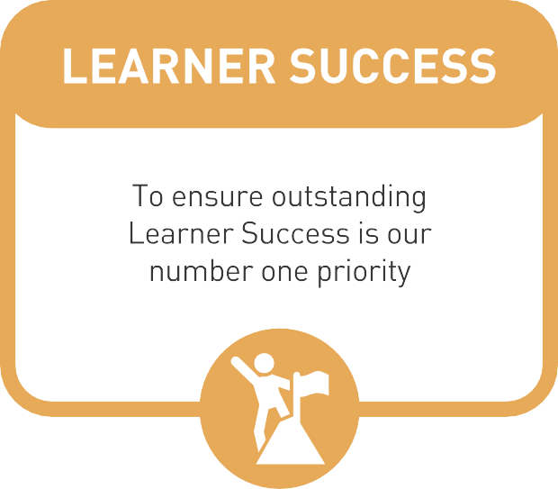
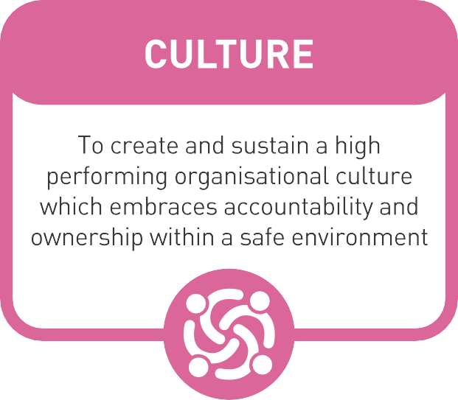
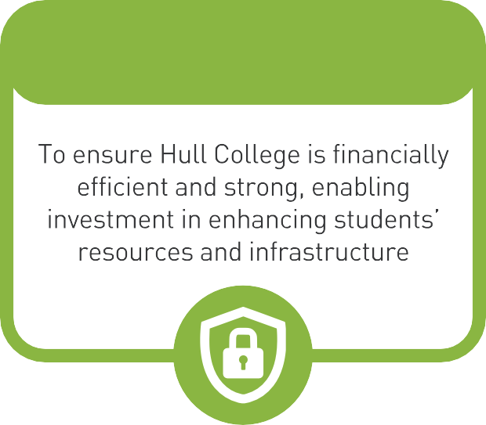
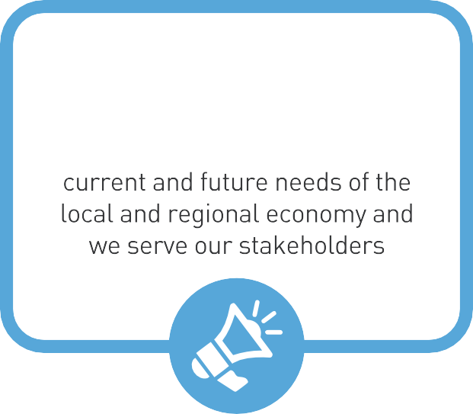

(FINANCIAL SECURITY)
BRAND & REPUTATION
To ensure our offer meets the

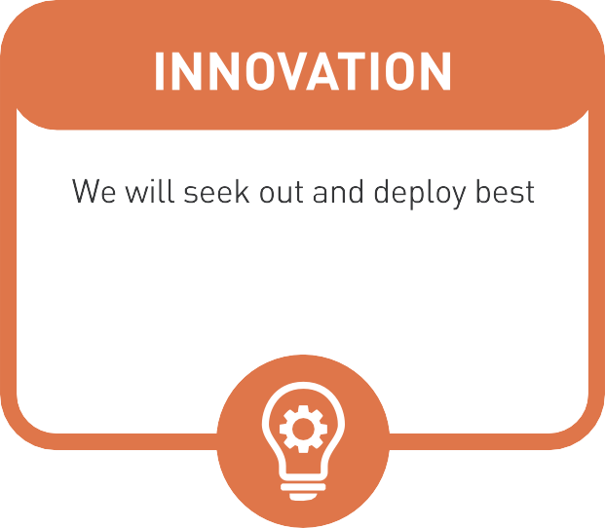
•
(
)
practice in the education and industrial sectors to improve
our prov1s1on
•
•
•

- • www.hull-college.ac.uk | 5

SECTION 2 CONTEXT AND PLACE

Hull College is situated in Kingston Upon Hull which is in the Hull and East Yorkshire region of England. Located north of the Humber Estuary the college’s main city centre site is known as the Queens Gardens. The college has two additional sites, they are in Nursery Grove where a small groundworks provision is delivered and the Cannon Street site which delivers advanced motor vehicle and welding programmes.

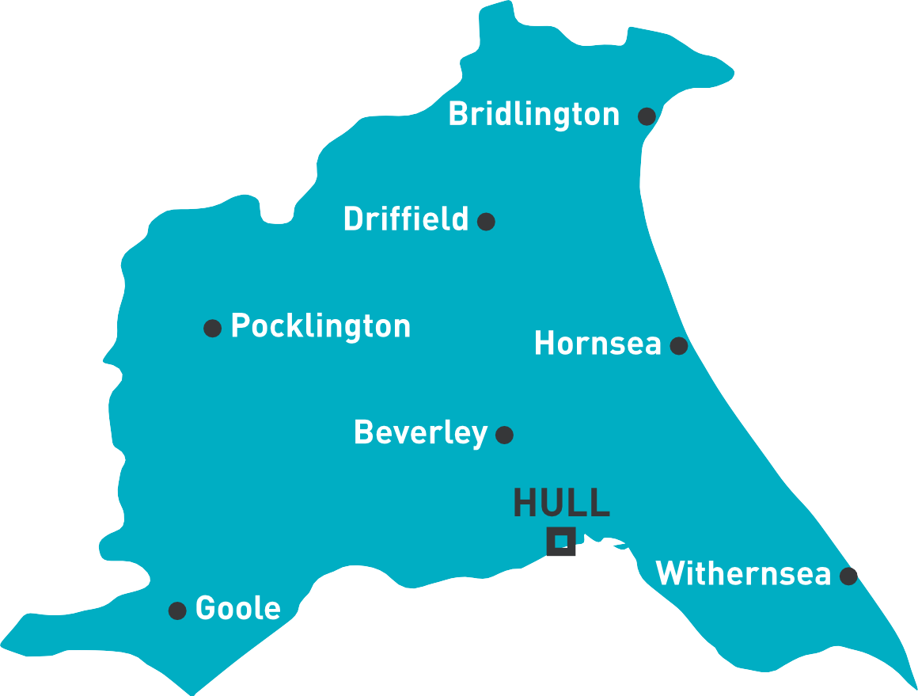

The college has a turnover of £30 million with approximately 6 thousand young people and adults studying approximately 15 thousand qualifications per year. The curriculum offer includes education programme
for young people aged 14-19, apprenticeships including those at higher level (level 4 and above), higher education, adult education, employability programmes, skilled bootcamps, sector-based work programmes, education to those who speak English as a second language, programmes for those with special education needs and disabilities.

The college services a significant proportion of the city’s most deprived residents. 75 percent of students and apprentices live in IMD decile one, this drops steeply when moving towards the more affluent areas of the city and the vast majority of students are resitting English and mathematics qualifications.

SECTION 2 CONTEXT AND PLACE

Review of levels of deprivation and the educational attainment of young people and adults in Hull makes for a startling read.

The national Index of Multiple Deprivation (IMD) 2019 shows that of 45.2% of Hull’s neighbourhoods are ranked in decile 1, the most deprived 10% in England. 13,664 (26.4%) of children in Hull live in families with absolute low income and 15,880 (30.7%) live in families with relative low income. This compares to national rates of 15.3% and 18.4%. Simply put nearly half of the city’s communities are the most deprived in England and more than half of the city’s children live in families with absolute or relatively low income.

Post-16 qualification attainment in Hull by age 19 remains concernedly low compared to regional and national levels, likely influenced by the city’s overall high deprivation rates. At age 19, the number of young people achieving a level 3 qualification lags 14.8% behind national rates and 9.7% behind the rate for Yorkshire
and Humberside. At level 2 young people fall 6.1% behind national rates and 2.6% behind Yorkshire and Humberside. In these measures, Hull is ranked 146 out of 150 local authorities in England for level 3 attainment and 131 out of 150 for level 2.

Inevitably, the attainment of adults at higher levels, level 4 and above, is weak. Currently only 21.7% of Hull residents hold a qualification at Level 4 and above compared with 33.9% nationally.

The HEY LEP Economic Growth and Well Being Strategy 2021-2026 predicts that 46% of jobs in the wider Humber region will require Level 4 and higher qualifications by 2030. And data shows attainment levels for adults and young people in Hull are falling further behind, not narrowing. Covid hasn’t helped. Hull City
Council report: “By May 2020, the impacts of the pandemic had immediately been seen in the labour market ... Young people, women, and those from black and minority ethnic communities have all seen greater impacts in the number of job losses, unemployment claimants, and those furloughed. These challenges confirmed the structural issues that existed before the pandemic, and which still require addressing.”

Hull College accepts this context as a challenge and not an excuse. This only serves to evidence the importance and impact of Hull College’s contribution to the communities it serves and thriving regional economy. It is Hull College’s commitment to support more Hull people into the jobs available to them.

SECTION 2 CONTEXT AND PLACE

IMD profile: this table illustrates that a high proportions of Hull College students reside in the cities poorest communities, this drops steeply and continues and enrolments decline further in the most affluent areas.
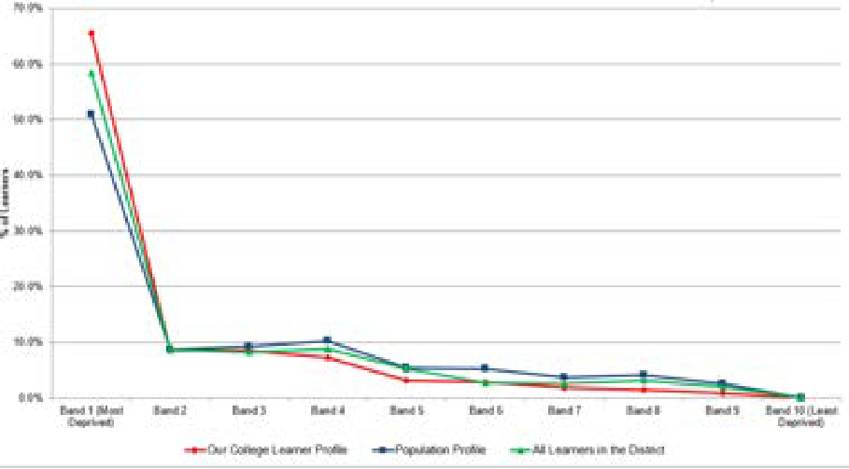
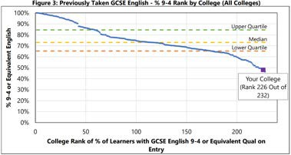
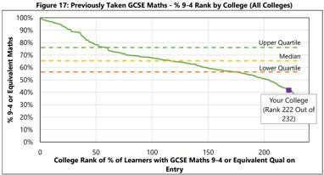

SECTION 3 MEETING LOCAL, REGIONAL AND NATIONAL NEEDS

‘Focused on the Future’ uses 3–5-year labour market intelligence trends from specialist providers such as Lightcast and Vector to assist the college in meeting local labour market needs, regional business demands and LEP priorities. This has influenced the college’s strategic work.
The college has been at the forefront of digital developments and has been instrumental in the Humber Digital Skills Partnership, we have leveraged the Humber Strategic Development fund to develop student skills in green industries and invest in our green technology infrastructure. This includes the successful implementation of an electric vehicle maintenance offer which has provided training to local garages and students and apprentices in electric vehicle technology since its inception in 2021. The college is now innovating further in this space with the introduction of a green skills innovation hub which will include wind, wave, geothermal and heat source low carbon energies.
The college has successfully participated in the delivery of strategic development funding to meet skills gaps in current and emergent areas across the region. The Hull College Employer Engagement Strategy sets out our plans for excellence in employer and stakeholder engagement within the Hull and Humber region, and national context. We have identified 5 key areas of strategic work towards achieving this, they are to;
- Implement an employer engagement model which provides excellent end to end services to our employers and stakeholders, and uses LMI and skills trends to drive employer services and engagement.
- Develop and enhance our well-established ways of engaging with and gaining feedback from industry as well as posing new ideas to employers through encouraging and supporting knowledge transfer initiatives which meet their needs and enables them to thrive and develop their business.
- Our Executive Leadership and Senior colleagues will seek strategic engagement with Local Enterprise Partnerships, Skills Improvement Planning and Chamber of Commerce locally, regionally and in a national context.
- Governors will champion and scrutinise market intelligence, employer voice and stakeholder views ensuring that they are primary to the colleges educational character.
- The college will understand and strive to meet the current and future skills needs of employers.
The college’s curriculum planning cycle takes explicit notice of the skills landscape in order to ensure our curriculum is fit for purpose and future proof. Data sources used in the planning process including LMI accessed via the Lightcast system and RCU Vector along with tangible local, regional, national, and international perspectives, emergent themes from the Hull and East Yorkshire Local Skills Improvement Plan, and city and region specific information sources such as Hull Council’s Economic Strategy; East Riding Economic Strategy; University of Hull Strategy; HEY LEP Economic Growth Strategy; Humber Estuary Plan; Net Zero – Build Back Better; Hull Industrial Cluster Plan; and the
UK Industrial Strategy.
Every curriculum area is underpinned by an expert panel made up of the employer and stakeholder community. Expert panels seek to understand the immediate and longer-term skills needs from a technical perspective and in terms of core employability. For example, our employers and stakeholders have shaped the college’s tutorial offer and contribute significantly to student professional development which addresses themes related to leadership, sustainability, wellbeing and digital.
The Hull and East Yorkshire LSIP identifies significant skills gaps across key sectors, with a growing need for higher technical skills, digital competencies, employability skills, and green skills driven by Net Zero. To address these challenges, the LSIP recommends expanding technical education pathways, boosting apprenticeship provision, providing modular upskilling opportunities, and strengthening employer partnerships. Improving core English, maths, and digital skills attainment is also a cross-cutting priority, as is better integrating employability skills across
all provision.
Through our relentless focus on skills gaps, skills need, and national priorities we are able to ensure that our curriculum responds to the LSIP - this is evidenced in the curriculum we deliver and ongoing curriculum and skills innovation.
The colleges Skills Advisory Board meets 4 times per year to support horizon scanning and curriculum implementation. During the last academic year the college increased its governance responsibility to skills in appointing a second skills link governor.

SECTION 3 MEETING LOCAL, REGIONAL AND NATIONAL NEEDS
 Under development for 23/24 and beyond  New programmes being introduced
23/24



 Currently available
GEOGRAPHICAL PRIORITY

SKILLED AREA | Local | Regional | National | Emergent
Construction |  |  | 
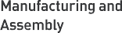  Manufacturing and Assembly |  |  | 
Digital and Technology |  |  | 
Health and Social Care |  |  | 
Haulage and Logistics |  |  | 
Engineering |  |  | 
Science and Mathematics |  |  | 
Low Carbon Technologies |  | 
Pharmaceuticals |  | 
Tourism and Culture |  | 
Space Technologies |  |  |  | 
Agri-Tech |  | 

 Currently available  Under development for 24/25 and beyond  New programmes being introduced
HULL COLLEGE CONTRIBUTION

SKILLED AREA | 14-19 | Apprenticeship | Adult employability programmes inc.  SWAPs and bootcamps | Higher education/ Higher apprenticeships
Construction |  |  |  |  
Manufacturing and Assembly |  |  | 
Digital and Technology |   |  |  |  
Health and Social Care |   |  | 
Haulage and Logistics |  |  | 
Engineering |  |  | 
Science and Mathematics |   |  | 
Low Carbon Technologies |  |  |  | 
Pharmaceuticals | The college has established representation from the pharma sector on its Skills Advisory Panel with the view of developing appropriate employer led programmes in the pharma industry.
Tourism and Culture | 
Space Technologies | Hull College recognises that Space Tech is an emergent sector. Just as low cardon tech has gathered momentum in recent years we predict that with the rising demand of automation will come a rising demand for space technologies and satellite system use.
Agri-Tech | Agri-tech is offered by a strong and long-standing post 16 provider in the region who specialise in agriculture programmes.
* The college maintains a solid foundation in each area of curriculum which is currently under development. The development relates specifically to new innovations and changes in curriculum to ensure that these areas continue to meet the rapidly changing economy .
 
  

SECTION 4 KEY STAKEHOLDERS

Our mission and purpose are directly aligned to the needs of our students, our employers and the communities we serve. Hull and East Yorkshire form part of the Humber industrial cluster with significant global trade movements through our region. Consequently, we work with a comprehensive range
of stakeholders to develop, refine, and implement our three-year strategic plan and our annualised operational plan.
A sample of the range of stakeholders we work with can be seen in the previous section on how we respond to local, national and region priorities, but in summary these include:
- The Growth and Skills Hub.
- The Hull Chamber of Commerce.
- The Yorkshire and Humber Confederation of British Industry.
- Hull City Council.
- East Riding of Yorkshire Council.
- Lightcast.
- Hull University Teaching Hospitals.
- Hull Clinical Commissioning Group.
- Individual businesses across the Humber and East Yorkshire region, including large levy businesses, SMEs and micro-businesses such as KCOM, Yorkshire Water, Reckitts, Smith and Nephew, Turner Price, Paneltex, Resq, and Wren Kitchens.
The college has established several city-wide, regional and national relationships. This includes large stakeholders in priority sector areas but not withstanding the corporate and commercial sectors which will underpin the transformation current evolving in the region, for example in legal, leadership and management and customer service, along with the emergent economies such as in the space technology and innovation sector.
We also support new initiatives in the Humber region including Humber Freeport Developments, Industrial decarbonisation, creation of a hydrogen economy, international trade and the City of Culture legacy developments.
The college maintains a small number of partners who deliver adult programmes in skilled professions. The college will only partner with providers in sector areas which contribute to local, regional, and national priorities. For example, as a contribution to the haulage and logistics sector the college partners with a training provider to deliver forklift and driving goods vehicle qualifications which the college do not have a directly delivered curriculum offer.

SECTION 5 ENGAGEMENT WITH OTHER PROVIDERS IN THE AREA

The college is an active member of the Hull Learning Partnership. The Vice Principal Curriculum and Skills Chairs the Post 16 Partnership Group which comprises of Hull’s sixth form colleges, independent training providers and the university technical college who work collectively on matters related to data sharing, transition planning, tackling NEET issues, SEND, curriculum development and careers and work experience. The group is attended by key members of Hull City Council including the Head of 14-19 Education, the Virtual School, and members of the HEY LEP. Members of senior staff regularly attend school liaison groups including the Secondary Heads Group, which follows a similar structure as the post 16 partnership.
We maintain effective relationships with Hull University through regular liaison at all levels of the organisations: faculty staff, middle leadership, quality colleagues and senior leadership. The college has established a curriculum exchange which seeks to support transition, progression opportunities, and co-design/delivery between Hull College and Hull University. Additionally, to this our respective organisations have concluded a curriculum mapping activity which has culminated in a shared collective understanding of where (provider type) and how (provision type) higher education curriculum will be delivered with each organisations taking the lead in areas which lend to our strengths.
The college sits on the council’s Health and Wellbeing Committee. This ensures close communication on wellbeing issues across the city between the college and local authority. Additionally, the college attends local groups regarding safeguarding and PREVENT.
We are an anchor partner for the Humber Digital Skills Partnership which includes colleagues from a range of Humber based businesses, representatives from other further education and 6th Form Colleges and Hull University.
We take a leading role in the Humber Principals Group where all executive leaders from every FE and College 6th Form in the region meet to discuss opportunities for collaboration and partnership working.
We work collaboratively with our FE and 6th Form college colleagues across the region to secure inward investment to the area. Examples of this include the Humber Strategic Development Fund which brought together eight Humber Educational partners and secured almost £5m of capital and revenue investment into our green and digital curriculums.
Hull College is the prime provider for ESF projects across the Humber region. We have worked collaboratively with education partners across the county to ensure these funds enable local businesses to thrive and secure retraining and upskilling.
Members of the college executive are active in the local skills landscape including our Principal and CEO who is the principal representative on the HEY LSIP Board and the Vice Principal Curriculum who is Vice Chair for the Growth and Skills Hub Skills Network.
Hull College also works with many other providers in the national educational arena including representation on the Energy Skills Consortium; Association of Colleges HE Policy Group; Association of Colleges Accountability and Quality Group; Association of Colleges Skills for Jobs White Paper Group; DfE National Digital Strategy Group; OFQUALs EDI Forum’ DfE Skills Reform Panel(s).

SECTION 6 REVIEW OF THE PRIOR YEARS

Too early to tell | At Risk | Partial | On Track

Reviewed as of June 2025
1: Continue to Increase achievement rates across all programmes, with a keen focus on apprenticeships and further education provision (study programme and adults) in skilled priority areas were achievement will be a minimum of 88% for further education; which equates to an improvement of 3%, and 65% for apprenticeships; which equates to an improvement of 5%.

Update:
- The college will meet the FE target. The revised apprenticeship target is 55%. Impact on/ contribution towards skills priorities
Outcomes in the Hull city region are particularly poor as with Level 2 and Level 3 outcomes reaching as high at 13% behind the national average, and there are not enough Level 4 skilled professionals. By increasing outcomes in skilled priority areas, we will enable more students to progress through the levels of learning at Hull College and enter the job market in high productivity sectors.
Key priority areas include;
- Health
- Early years education
- Construction
- Engineering
- Low carbon technologies
- Digital
This links to key priority 1
2: English and maths outcomes to be in line with the regions average which equates to a 29% increase in functional skills English and maths and 15% increase in GCSE English and maths. This will be achieved through the implementation of an English and maths strategy which places skill development as priority so
that students develop their confidence in a range of communication styles and become active problem solvers.

Update:
- FE outcomes have improved and attendance to GCSE exams have improved year on year. Impact on/ contribution towards skills priorities
The level of English and maths attainment at Hull College is too low, this is symptomatic across the city. Increasing English and maths outcomes will support skills growth and generation of new skills and talent in key priority sectors including;
- Health
- Construction
- Engineering
- Low carbon technologies
- Digital

This links to key priority 1

www.hull-college.ac.uk | 13

3: Secure positive destinations for students and apprentices so that a minimum of 90% of students and apprentices either secure work in skilled professions and/ or continue education in priority sectors.
Update:
- It is likely that the college will meet or exceed this target. External validation suggests excellent progression for learners into employment and then within their job role, and internal destination capture which closes at the end of term is consistently positive.
Impact on/ contribution towards skills priorities
By increasing positive progression into employment and further education more Hull residents will benefit from the job opportunities available to them, specifically through apprentices, study programmes and bootcamps in skills priority sectors;
- Digital
- Health
- Construction
- Manufacturing
- Engineering
- Low carbon technologies This links to key priority 1
4: Develop a bespoke training and development plan held centrally to facilitate specific industry 4.0 training based on and individual needs basis and to prioritise the ‘back to the floor’ initiative for technical staff;
- 90% of staff teaching on these programmes will undertake industrial upskilling which enables them to teach the curriculum of the future identified in
- 100% staff will participate in ‘Back to the Floor’ in key priority sectors;
- Train 90% of teaching staff on using AI technologies in their teaching practices by year end to ensure effective integration;
Update:
- We continue to develop and innovate in our commitment to ensure all staff have access to ‘Back to the Floor’ initiatives
Impact on/ contribution towards skills priorities
The People Strategy will directly influence the college capacity towards developing a skilled workforce able to deliver the skills of the future and that which is aligned to the city, region and national priorities. This is most relevant to developing the work force in digital, low carbon, engineering and construction.
This links to key priority 2 and 4
5: Continue to growth and diversify in the digital, engineering, construction, health care and low carbon sectors by increasing access and participation in these areas and introducing new programmes and delivery methods.
- Participation in these areas will expand across the East Riding region branching further afield and into new markets.
- The roll of SWAPS will continue to priorities these subjects.

Update:
Growth has occurred in each of these priority areas and applications suggest continued growth into AY 25/26. Impact on/ contribution towards skills priorities

This will ensure that more people enter the labour market in priority sectors. Curriculum innovation described in action point 1 showcases how these areas directly align to sections 2 and 3 and that of the Local Skills Improvement Plan and Local Enterprise Partnership, and national priorities.
This links to key priority 1 and 5
6: Launch new curriculum areas and invigorate withstanding curriculum so that the offer is directly aligned to sector need and seeks to improve educational attainment:
- Create and launch ‘Space’ provision on elevate. With 100 enrolments, 90% satisfaction and 90% achievement.
- Prepare for the introduction of the HND in Aeronautical Engineering in AY 25/26.
- HE curriculum plan developed and approved for the next 5 years.
- Launch 21st Century Skills Passport.
- Launch an interdisciplinary drone academy.
- 50% of vocational program students receive training in relevant cross-disciplinary technologies, with at least 50% demonstrating proficiency in these tools by the end of their course.
- Launch AI Academy for students and businesses monthly.

Update:
- There has been continued innovation and development in Hull Colleges curriculum offer. Impact on/ contribution towards skills priorities
Young people, adults and apprentices will be able to access relevant modes of delivery enabled them to engage in programmes which are aligned to skills needs. Each curriculum area links directly to skills needs, LMI and the colleges core priorities. These areas will impact on skill development and labour market entrants in health, digital, science, engineering, construction, low carbon technologies, and the corporate sector.
This links to key priority 1, 4 and 5
7: Develop new curriculum and technical resources to deliver low carbon technologies and sustainability in construction by building a green skills innovation hub which provides hands on skills training in these priority areas;
- Introduce taught modules in renewable transport, sustainability in the green energy sector, health and safety in the green energy sector, renewable energy technology, heat source pumps (ground source pumps, water source heat pumps and air source pumps), understanding. decarbonisation, and the fundamentals of energy. Partially met.
- Introduce a Foundation Degree in sustainability. Not met – will roll into next year.
- Introduce a Foundation Degree Renewable Technology. Not met – will roll into next year
Update:
- There has been continued innovation and development in Hull Colleges curriculum offer specifically aligned to low carbon technologies and we continue to prioritise in this area
Impact on/ contribution towards skills priorities
This area of work has a direct impact on the low carbon, engineering and construction sectors, and will ensure that more people are educated in these priority sectors and able to access the emergent jobs of the future.
This links to key priority 1, 4 and 5



SECTION 7 2025/2026 OBJECTIVES

- Empowering Success - Unlocking potential and transforming lives for every student, staff member, and community we serve
- Bold and Inclusive Culture - An environment where ambition thrives, diversity is celebrated, and everyone rises together.
- Resourceful and Resilient - Sustaining growth and innovation with strength, agility, and a positive approach to opportunity
- World Class Brand and Influence - A trusted college, creating impact locally, regionally and nationally and influencing globally
- Driven by Innovation - Breaking barriers and reimagining education for tomorrow.

ACTION 1
Continue to Increase achievement rates across all programmes, with a keen focus on apprenticeships and further education provision (study programme and adults) in skilled priority areas where achievement will be a minimum of 90% for further education; and 60% for apprenticeships.

Impact on/ contribution towards skills priorities
Outcomes in the Hull city region are particularly poor as with Level 2 and Level 3 outcomes reaching as high at 13% behind the national average, and there are not enough Level 4 skilled professionals. By increasing outcomes in skilled priority areas, we will enable more students to progress through the levels of learning at Hull College and enter the job market in high productivity sectors.
Key priority areas include;
  - Health
  - Early years education
  - Construction
  - Engineering
  - Low carbon technologies
  - Digital
This links to key priority 1

SECTION 7 2025/2026 OBJECTIVES

ACTION 2
English and maths outcomes to be in line with the regions average. This will be achieved through the implementation of an English and maths strategy which places skill development as priority so that students develop their confidence in a range of communication styles and become active problem solvers.

Impact on/ contribution towards skills priorities
The level of English and maths attainment at Hull College is too low, this is symptomatic across the city. Increasing English and maths outcomes will support skills growth and generation of new skills and talent in key priority sectors including;
- Health
- Construction.
- Engineering
- Low carbon technologies
- Digital
This links to key priority 1

ACTION 3
Secure positive destinations for students and apprentices so that a minimum of 90% of students and apprentices either secure work in skilled professions and/ or continue education in priority sectors.

Impact on/ contribution towards skills priorities
By increasing positive progression into employment and further education more Hull residents will benefit from the job opportunities available to them, specifically through apprentices, study programmes, and bootcamps in skills priority sectors;
- Digital
- Health
- Construction
- Manufacturing
- Engineering
- Low carbon technologies This links to key priority 1

ACTION 4
Delivery a workforce development plan that facilitates specific industry 5.0 training and ‘back to the floor’ initiative for technical staff.

Impact on/ contribution towards skills priorities
The People Strategy will directly influence the college capacity towards developing a skilled workforce able to deliver the skills of the future and that which is aligned to the city, region and national priorities. This is most relevant to developing the work force in digital, low carbon, engineering and construction.
This links to key priority 2 and 4

SECTION 7 2025/2026 OBJECTIVES

ACTION 5
Launch new curriculum areas and invigorate withstanding curriculum so that the offer is directly aligned to sector needs, industry 5.0, and advancing technology
  - Develop formalised additional bite size qualifications, and our modular learning in the use of hydrogen, robotics and mechatronics, heat source, retrofit
  - Continue to roll out the online space series
  - Introduce an appropriate space pathway into the engineering curriculum at L2
  - Diversify our SWAP provision to include Manufacturing, renewables, construction trades and retrofit
  - Introduce new curriculum pathways in advanced welding techniques and metal fabrication / plate working, in response to Carbon Capture investment (circular welding)
  - Develop and implement distinct health pathways at Level 3 covering social and medical professions
  - Develop and implement non-regulated learning in AI related to specific technical disciplines in each key priority sector
  - Develop and implement non-regulated learning in cyber security within the digital curriculum

Impact on/ contribution towards skills priorities
Young people, adults and apprentices will be able to access relevant modes of delivery enabled them to engage in programmes which are aligned to skills needs. Each curriculum area links directly to skills needs, LMI and the colleges core priorities. These areas will impact on skill development and labour market entrants in health, digital, science, engineering, construction, low carbon technologies, and the corporate sector.
This links to priority 1, 4 and 5

SECTION 8 LOCAL NEEDS DUTY

The governing body regularly reviews how Hull College is meeting local, regional and national skills needs through several mechanisms that enable both long-term strategic planning and near-term operational oversight.

Key processes include the annual curriculum planning cycle, which ensures alignment to priority sectors and labour market demand; the 3-5 year strategic plan “Focused on the Future,” which takes an outward-looking approach to position the college at the forefront of changing skills needs; and the new “Skills Strategy 2023-2026. The Skills Strategy provides a longer-term approach to curriculum and skills development. This year’s accountability statement focuses on addressing urgent curriculum needs it supports longer term plans for
a level 4 offer in health care, engineering, low carbon technologies, manufacturing, construction, the built environment, and digital.

Together these mechanisms of review enable regular scrutiny of how the college serves its communities by filling skills gaps, avoiding duplication, and collaborating with partners like the University of Hull on aligned HE curriculum. Collaboration remains crucial; work continues with the University of Hull to align higher education curriculum and enable clear progression pathways. The college is developing a revised offer which focuses
on Higher Technical Skills in key priority sectors including, for example, the introduction of higher-level study in renewable energy and investment into circular welding, paramedic care, bariatric care, and artificial intelligence and virtual reality to support higher level pathways in health care.

While meeting economic needs, developing wider employability skills and raising aspirations remains a priority. Introduction of a Skills Advisory Panel and the annual Accountability Agreement further support strategic review. This will help the college in maintaining a strong connection with industry so that our offers remain agile, responsive and future focused.

The Corporation continues looking outward, responding agilely to changing regional, national and global skills landscapes. This multifaceted approach enables the Corporation to ensure that Hull College leads on technical education, boosting productivity and inclusive growth across the Humber region.

SECTION 8 CORPORATION STATEMENT

On behalf of the Hull College Corporation, it is hereby confirmed that the Corporation conducts reviews in line with the local needs duty, as such resulting in this plan. The annual accountability statement sets out an agreed statement of purpose, aims and objectives as approved by the corporation.

The plan will be published on the college’s website within three months of the start of the new academic year and can be accessed from the following link: www.hull-college.ac.uk/governance






ROB LAWSON DEBRA GRAY
CHAIR OF GOVERNORS PRINCIPAL AND CEO / ACCOUNTING OFFICER

Dated: 20/05/25

Reference to Relevant Supporting Documentation
College’s should provide links overleaf to any other key documents that are referred to or directly relevant to the college plan, such as LSIPs; annual financial statements; performance dashboards; and Ofsted inspections.

SECTION 9 APPENDICES AND REFERENCE SOURCES

References and links
Focused on the Future
Hull Council’s Economic Strategy; East Riding Economic Strategy; University of Hull Strategy;
HEY LEP Economic Growth Strategy; Humber Estuary Plan;
Net Zero – Build Back Better; Hull Industrial Cluster Plan; and the UK Industrial Strategy.
The college routinely applies learning from wider economic and social thinktanks Speed of Skill Change;
Demographic Drought;
2022 Talent Playbook ;
The Logistics Skills Gap;
Digital Skills - Talent Forecast and McKinsey & Company



